OOP Assessment Stage 10

For this stage you should add the following functionality to your system-
- Staff Function- Deleting a selected Product.

- Deleting a Product

This function is for Staff members and is run via the Staff Members Home -> Modify Products -> Delete Product
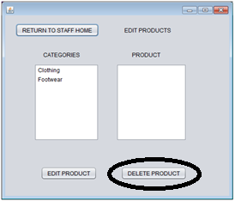

Create the DBManager method which has 1 input parameter- the Product Id (int), using this and a DELETE SQL Statement you should delete a product from your database based on the input ProductId.

Once you have done this connect this up to your ProductMenu that the Staff can see and the 'Delete Product' button.
When deleting a Product it should also be removed from the listBox and a success message shown.

Once implemented fully- test by deleting both a Clothing AND Footwear product and ensure that these products are deleted from within your database.

